8. Implement Boosting Technique (AdaBoost) and Analyze Performance
Aim:
To implement the AdaBoost classification algorithm using Python and analyze its performance using accuracy, precision, recall, and F1-score.
Algorithm:
- Start the program.
- Import the required libraries from Scikit-learn.
- Load or create a dataset containing input features and target labels.
- Split the dataset into training and testing sets.
- Create an AdaBoost classification model.
- Train the model using the training data.
- Predict the output using the testing data.
- Calculate accuracy, precision, recall, and F1-score.
- Display the evaluation metrics and analyze the model's performance.
- Stop the program.

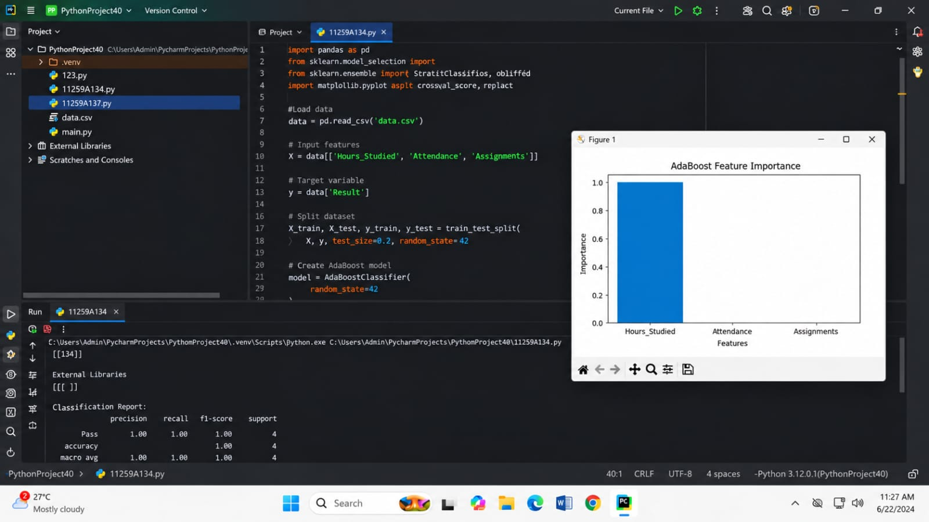
CODE AND OUTPUT:
Result:
Thus, the AdaBoost classification model was successfully implemented using Python, and its performance was analyzed using accuracy, precision, recall, and F1-score.

